KNN - nearest neighbours

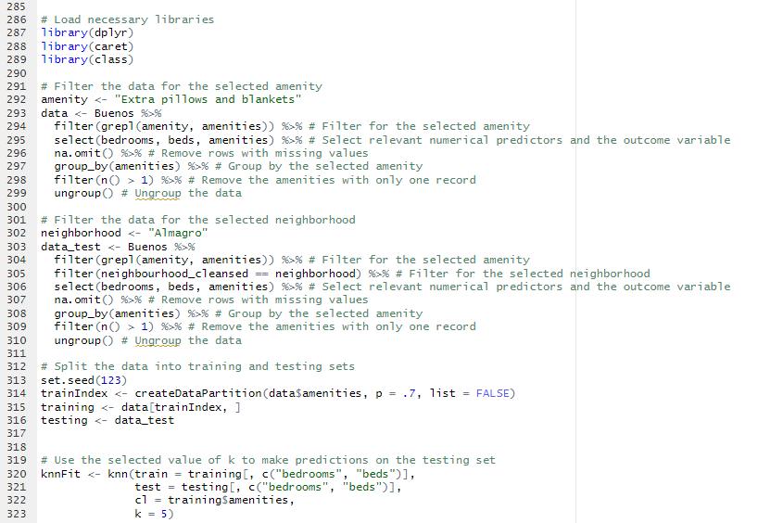

In this analysis, we used k-NN classification to predict the presence of the "Extra pillows and blankets" amenity in Airbnb listings in Buenos Aires. We first filtered the dataset to include only listings that had this amenity and selected the relevant numerical predictors (bedrooms and beds). We then split the data into a training set (70% of the data) and a testing set to be the Almagro data. The k-NN model was trained on the training set, with k set to 5, and the model was used to predict the presence of the amenity in the testing set.

The k-NN model works by finding the k nearest neighbors to a new data point in the training set based on the selected predictors (in this case, bedrooms and beds). The predicted class for the new data point is determined by the majority class of its k nearest neighbors. In this analysis, we predicted the presence of the "Extra pillows and blankets" amenity in the testing set based on the bedrooms and beds of each listing.

The choice of k=5 in this example was made using 10-fold cross-validation, which is a common method for selecting the optimal value of k in k-NN classification. The cross-validation process involves splitting the training data into 10 smaller subsets, and then iteratively training the model on 9 of the subsets and testing it on the remaining subset. This is repeated 10 times, with each subset used for testing exactly once. The performance of the model is then averaged across all 10 iterations to give an estimate of its overall accuracy.

Predictions in the testing set with k=5

49 Levels: ["Changing table", "Extra pillows and blankets", "Dishes and silverware", "First aid kit", "Wifi", "Oven", "Fire extinguisher", "Host greets you", "Stove", "Kitchen", "Cooking basics", "Security cameras on property", "Coffee maker", "Smoke alarm", "Crib", "Luggage dropoff allowed", "Shampoo", "Essentials", "Hair dryer", "Bed linens", "Carbon monoxide alarm", "Paid street parking off premises", "Private entrance", "Microwave", "Hangers", "Iron", "Air conditioning", "Refrigerator", "Window guards", "Shared patio or balcony", "Backyard", "Long term stays allowed", "Heating", "Washer", "Hot water", "TV with standard cable"] ...